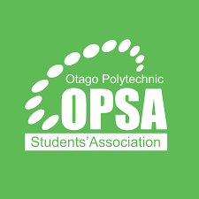

Otago Polytechnic Students’ Assn
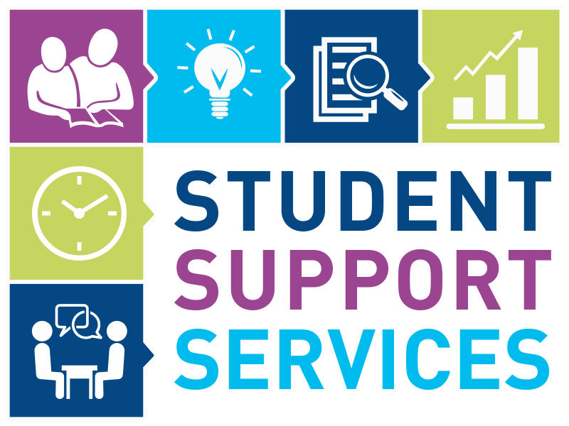

Distance Learners

OPSA welcomes you to study at Otago Polytechnic. We wish you success in your studies and hope you find your experience productive and satisfying.

Please use this handbook as a resource, but also remember that many dedicated staff at Otago Polytechnic and OPSA are willing to assist you. Don’t hesitate to use the contact information in this handbook and your course information materials to assist with other questions.

USEFUL CONTACTS

OPSA – Otago Polytechnic Students’ Association is an independent organisation within the Polytechnic and is run by students for students. We provide student services on behalf of the Polytechnic, including facilities, advocacy and representation.

Feel free to contact OPSA anytime with any queries, concerns or issues you may have

OPSA Advisory Board President/Chair:

Daiiz Rongo opsaprez@op.ac.nz 021 091 54944

Student Support Advisor

Lesley Scoullar Lesley.scoullar@op.ac.nz 027 611 7795


Office manager

Rammy El-Dessouky rammy.eldessouky@op.ac.nz 021 058 7863

Telephone: OPSA Office (03) 470 7792 0800-762-786

www.OPSA.org.nz www.opsa.org.nz/facebook

STUDENT SUCCESS TEAM 0800 762 786 studentsuccess@op.ac.nz

Campus life can be exciting and challenging, so our Student Success Team is here to support you and help you through any issues that might arise. Contact them to seek help for any issues impacting your opportunities to study or fully engage in your learning.

Advisors are available to discuss opportunities and support with Careers, Learning advises Pasifika, Wellbeing and Accessibility.

Our Services include:

- Academic support
- Access to counselling
- Pasifika support and scholarships
- Advocacy
- Career guidance
- Pastoral care
- Adjustment to student life
- Balancing workload and family commitments
- Isolation and relocation issues
- Removing barriers for students with disabilities
- Health concerns and referrals
- Referral to community and government agencies
- Wellbeing

Student Success after-hours emergency support. 24/7: (64) 021 735 421

CHAPLAIN

- Chaplains are here to support you in your journey at Otago Polytechnic. Specifically, they provide:
- Spiritual guidance
- Faith-based support
- Grief care following significant life events

- Available over the phone, via video call or email. We also have a Māori chaplain available

Steve Downey chaplain@op.ac.nz 021 338 800
Te Ata Roy maori.chaplain@op.ac.nz 027 7025 966
Muslim Chaplain muslimchaplaincy@otago.ac.nz

COUNSELLING
If you require counselling, please contact:

- Student success on 0800 762 786 or email studentsuccess@op.ac.nz or contact

- Student Health https://www.op.ac.nz/students/support/tile?id=179 0800 762 786

- Telecounselling services (Sessions available seven days a week, 9 am-9 pm). Enrol online: https://puawaitanga.nz/

- Vitae Counselling Services Tari Whakapakari Ngākau is a free, 24/7. Available in-person, via phone or Zoom. Enrol online: https://www.vitae.co.nz/Te-Pukenga/ or phone: 0508 664 981

IT SUPPORT SERVICE DESK



0800 765 948 email servicedesk@op.ac.nz to contact our IT Service Desk Staff.

8 am to 5 pm - Monday to Friday, fully staffed
We can provide support and advice for most IT difficulties you may encounter on Windows or Apple computers, including the computers you might be using from home.

Distance Students: Remember, we are here to help should you need it.

LEARNING ADVISORS

0800 762 786 studentsuccess@op.ac.nz
The team of Learning Advisors offer support in the skills you need for success in your course. Contact us by phone or email to let us know the support you need.

Internet sessions using your computer for Teams, Zoom or email feedback on written work are all available.

Te Punaka Owheo
Services for Māori Students include scholarship information, counselling, study/financial support, etc.
Phone: 0800 762 786 (Ask for Te Punaka Owheo)
Email: tepunakaowheo@op.ac.nz
Website: https://www.op.ac.nz/explore/student-experiences/maori-culture-support/

PASIFIKA SUPPORT
Services for Pasifika Students include scholarship information, counselling, study/financial support, etc.

Contact: Matilda Garrett or Fa’ao’o Lale, Student Advisor - Pasifika pasifika@op.ac.nz

LIBRARY SERVICES
0800 346 827 (answerphone) (03) 479 8940
www.moodle.op.ac.nz
distance.library@otago.ac.nz or lending.robertson@otago.ac.nz
https://otago.libguides.com/distance?_ga=2.185612201.1872353738.1541020281-1672913178.1539814630
The distance library services is for students living outside Dunedin and can use the service to request library material or ask for research assistance.

- There is an online ‘distance form’ to make requests for library material and free postage is provided for the return of books supplied by this service.
  - Allow 5-7 days for your requests to arrive – sorry, no urgent/priority service is available
- Go to the distance learners on the library website for more information

HAVING PERSONAL OR COURSE-RELATED PROBLEMS?
Learners who are experiencing personal or course-related problems are welcome to approach OPSA for confidential assistance or advice – email Lesley.scoullar@op.ac.nz or Rammy.eldessouky@op.ac.nz, or see the contacts page for telephone details.

Other handy contact

Otago Polytechnic 0800 762 786 all departments & services www.op.ac.nz
StudyLink 0800 88 99 00 www.studylink.govt.nz
Otago Polytechnic Studylink Specialist amanda.mcara@op.ac.nz

USEFUL SERVICES & RESOURCES
Don’t forget your Learner ID Card – order today if you haven’t already idcards@op.ac.nz

Remember, we are not given a list of distance learners, so you need to contact us to receive your id card

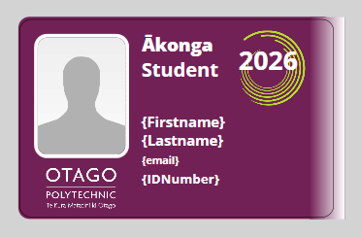

OPSA-Learner ID Card

As a distance student, you are usually charged for a student ID card and a student services fee.
Students studying off the Dunedin campus are NOT charged for services they cannot access
Some courses may not charge a Student Services Fee, so an alternative “Student Access” card is available to obtain ID/ library services.

ID Cards are processed at the OPSA Office and returned by post – replacement cards cost $25.00

- Email your details (including ID number, name & return address) and attach a photo in jpg. format (plain background, no sunnies or hats)
- Please email: idcards@op.ac.nz
- This card will also be your access to:
• Robertson library services, discounts throughout the country and Student Job Search.

FINANCIAL SUPPORT

OPSA also manages financial support for hardship or special projects and can provide information on assistance that may be appropriate and available, including emergencies.
We administer a student hardship fund, which may offer a grant or advice to Learners experiencing difficult “one-off” unforeseen financial hardship.

Contact to request a form: Lesley.scoullar@op.ac.nz or Rammy.eldessouky@op.ac.nz

Studylink – Special Needs Grant

www.studylink.govt.nz Check out what is available – a one-off payment may help with urgent things like food, bedding and emergency dental or medical treatment. You may be eligible if you have urgent and necessary needs and cannot meet these costs.

You can book an appointment with the Study link specialist if you need further information or support. https://outlook.office365.com/book/bookingsstudentsuccess@op.ac.nz/
COMMUNICATIONS
Check your student email for updates and DAILY updates on our Facebook page
Important notices/events will be posted on your student hub and www.opsa.org.nz/facebook

HARASSMENT & BULLYING
You have the right to enjoy your time at OP without being made uncomfortable about your age, gender, race, religion, or sexuality. If you think you are experiencing harassment from another student or a staff member, contact OPSA to speak with a contact person.



LANDLORD ISSUES
You have specific legal rights under the Residential Tenancies Act; check them out at Flatting 101: www.dbh.govt.nz/flatting-101

The best approach is to first talk to your landlord about what’s wrong and say what a good solution might be. If that doesn't work, send the landlord a letter. If that doesn't work, contact Tenancy Services at www.dbh.govt.nz/tenancy-index. They may be able to help, or you can take the issue to mediation at www.dbh.govt.nz/tenancy-mediation

If the mediator or Tribunal make an order that the other party does not meet, there are steps to take to enforce an order www.dbh.govt.nz/tenancy-orders

OP POLICIES
Otago Polytechnic has policies governing how it operates, e.g. withdrawals and refunds, personal information, complaints procedures, harassment and bullying, etc. If you’d like a copy of any of these, please contact OPSA.
https://www.op.ac.nz/about/governance-and-leadership/policies

OPSA ON FACEBOOK
Become a friend of OPSA, keep up with the latest news, etc.
 opsa.org.nz/facebook

PARKING
If you are coming to Dunedin to attend a block course – limited street parking is available around campus – BUT CHECK to ensure you are parking in the right spot!


- Do not park in any staff (numbered) parks on campus sites/student village, or you will be towed.

REPRESENTATION
- OPSA has representatives on various Polytechnic boards and committees and regularly meets with management. If you have any concerns or views you wish to convey as a distance learner, please do not hesitate to let OPSA know.


STUDENT JOB SEARCH

SJS is a nationwide agency set up by student associations to help find students who work while studying. They have a high success rate, and a huge range of jobs in lots of different areas.
- It is free to use
- You can register online at www.sjs.co.nz or contact the team by calling 0800-757-562.

SUPPORT & COMPLAINTS (external)

OPSA is also here to assist with support and advocacy for your external complaints if it affects your study or to link you up with someone who can

Free Legal Advice www.communitylaw.org.nz

Citizens Advice Bureau www.cab.org.nz

Ministry of Education www.minedu.govt.nz

Dept of Building & Housing www.dbh.govt.nz

Employment Relations www.dol.govt.nz/er

Immigration Service www.immigration.govt.nz

Insurance Ombudsman www.iombudsman.org.nz

Human Rights Commission www.hrc.co.nz

Consumer Information www.consumeraffairs.govt.nz/for-consumers

Police Complaints www.police.govt.nz/contact/complaints.html

Debt Collectors & your rights www.consumer.org.nz/reports/debt-collectors

Utilities Disputes www.usl.xo.nz 0800 22 33 40 info@udl.co.nz
  - Free service sorting your complaints about electricity, gas and water

STUDENT HEALTH

Students studying in distant locations will be able to access our online healthcare service provided by Pocket Lab. Pocket Lab provides simple, fast healthcare online, through their app or by phone.

Book appointments, including same-day appointments, with NZ doctors

Get prescriptions, medical certificate, advice and referrals

Access care from anywhere in New Zealand

Pocket Lab services are available 8am to 10pm, 7 days a week.

For more information about our student health service, visit studentsupport.op.ac.nz/health-and-wellbeing contacts

(09) 869 2444 www.pocletlab.nz hello@pocletlab.nz

STUDENT HUB https://kapehu.op.ac.nz/

Access to your student information, including results, important dates, etc.

You can also make a comment, complaint or suggestion

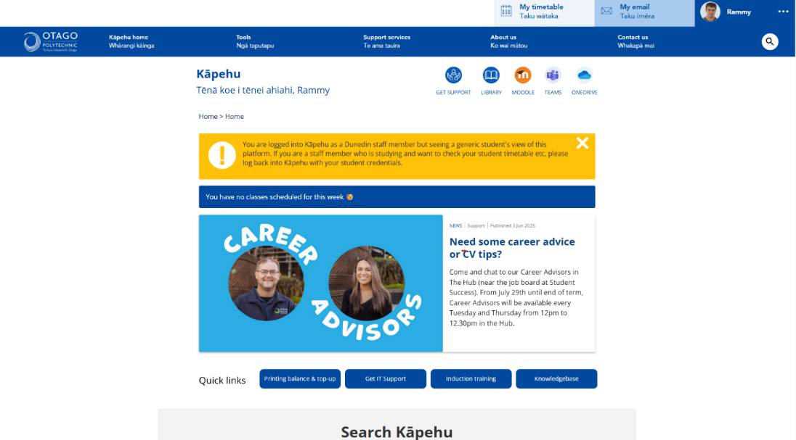

Why have a Students’ Association?
Complaints & Advocacy:
As well as offering services and facilities, OPSA is here to help and stand up for your rights when you need specific advocacy or have a complaint. A students' association is an insurance policy that there will always be someone to help you when you need it.

Representation:
OPSA is also here to make sure these rights exist in the first place, and that complaints are seldom necessary, by representing your opinion and needs so they have an influence over local and national decision-making.
It is about having someone representing you, keeping an eye on policies and decision-making to protect your rights, so you can spend time focusing on your studies.
NO MEMBERSHIP REQUIRED – all enrolled Learners automatically belong to
your Students’ Assn - OPSA

